डकुमेन्टमा आवश्यक परीवर्तन गरी 80 gsm paper मा प्रिन्ट गर्नुहोला ।
Saral Online Sewa Pvt.Ltd
Teku Hospital Gate, Teku , Kathmandu
टेकु अस्पताल गेट ४० मि अगाडी
WhatsApp : 9811786100 | Website : saralonline.com.np
Our Services
- F3 dependent Visa documentation.
- Visa Cover letter
- Visa Application Form
- Invitation Letter Typing
- Guarantee Leter Typing
- MOFA consular Relation / Marriage online form
- Flight Bookings
- Embassy Photo
- Arrange documents before visiting KVAC.
- C-3-1 Family Visit visa documentation
डकुमेन्ट बनाउनु परेमा WhatsApp:+977-9811786100

Location : https://maps.app.goo.gl/2zJWvtihEE8rQAUy8

COVER LETTER
Date: 2026/11/23

To,
The Visa Officer
Embassy of the Republic of Korea
Ravibhawan, Kathmandu, Nepal

Subject: Application for F-3 Dependent Visa

Dear Sir/Madam,

I’m writing this letter to provide all the details about myself and why I am applying for a dependent visa for the Republic of Korea.

I am [ Applicant Name ] a Nepalese citizen with passport number [Passport number] a permanent resident of [address], Nepal. My husband, [Husband's Name], has a Korean Alien Registration Card (No. [Card Number]). He has been working in South Korea for [Number of years] years. We have lived apart for a long time, and he has invited me to stay with him. Living together will help us support each other as a family.

I am applying to reside in the Republic of Korea solely as a dependent under my husband’s sponsorship. My husband maintains stable employment and sufficient financial resources to fully support my stay, assuming complete responsibility for all my accommodation, living, and incidental expenses. During my residence, I will not engage in unauthorized employment, and I commit to strictly abiding by all Korean immigration regulations and domestic laws. Furthermore, I guarantee that I will depart the Republic of Korea prior to the expiration of my authorized period of stay.

Enclosed are the following documents for your kind review:
- My valid passport and copies
- Completed visa application form / Cover letter
- Recent passport-sized photographs
- Certificate of relationship or marriage
- Travel Itinerary
- Supporting documents from Korea

I humbly request you to consider my application and grant me the F-3 dependent visa. Please feel free to contact me if any additional information or documentation is required. Thank you for your time and attention.

Sincerely,

[Your Full Name]
[Your Contact Information]

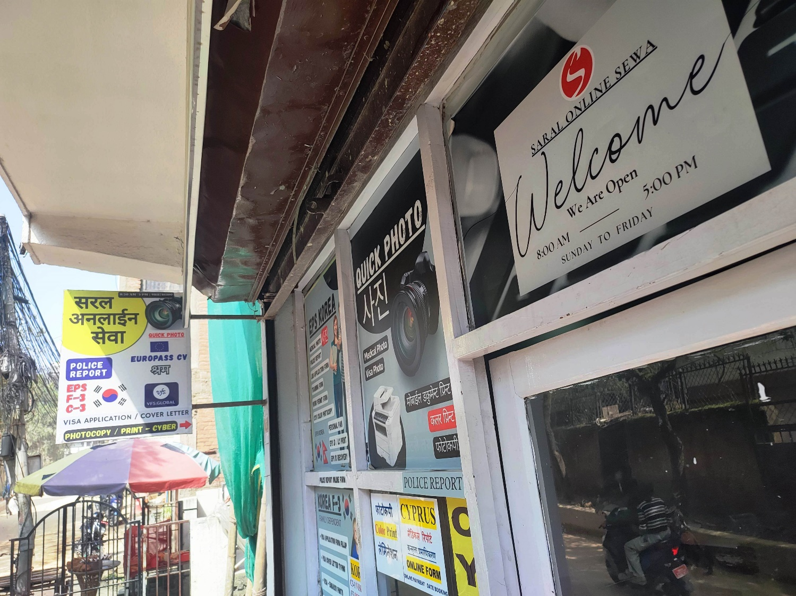

Thank You Very Much!!

Please Subscribe our Youtube and Tiktok Channel

https://www.youtube.com/@saralonline

www.tiktok.com/@saralonline

