डकुमेन्टमा आवश्यक परीवर्तन गरी 80 gsm paper मा प्रिन्ट गर्नुहोला ।

सरल अनलाईन सेवा
हाम्रो सेवाहरु
- डकुमेन्ट टाईपिङ, प्रिन्टिङ
- कलर प्रिन्ट
- भिसा फोटो (Embassy Photo)
- फोटोकपी
- विविध अनलाईन फारमहरू
- विविध कम्प्युटर सेवाहरु

टेकु अस्पताल गेट ४० मि अगाडी
Location : https://maps.app.goo.gl/2zJWvtihEE8rQAUy8
WhatsApp: 9811786100
saralonlinesewa@gmail.com
2025/06/23
To,
The Visa Officer
Embassy of the Republic of Korea
Ravibhawan, Kathmandu, Nepal
Subject: Application for F-3 Dependent Visa
Dear Sir/Madam,
I am writing to apply for an F-3 Dependent Visa to join my spouse, who is currently living in South Korea under an E-7 visa.
I am [Your Name], a Nepali citizen with passport number [Passport No.], and a permanent resident of [Your Address]. My husband, [Husband's Name], holds a Korean residence card (No. [Card-Number]) and has been working in South Korea for the past [Number of years] years. He has kindly invited me to join him. It has been a long time since we last spent time together, so I have decided to apply for a dependent visa to stay with him for a certain period of time. This will help us maintain a healthy family relationship.
I am confident that my husband's stable financial situation, along with his responsible and hardworking nature, ensures that he can fully support my living expenses during my stay in South Korea. I understand my responsibilities as a dependent and assure you that I will follow all the rules and regulations of South Korea. I respect the country's laws and am prepared to integrate into Korean society.
I sincerely request you to consider my application. I assure you that I will follow all visa conditions and leave South Korea before my visa expires.
Attached Documents:
- Visa Application Form  - Invitation letter  - Guarantee Letter  - Residence Card  - Lease Contract  - Certificate of Employment  - Business Registration Certificate  - Personal Bank Statement  - Seal Certificate  - Labour Contract | - Passport Original & Photocopy  - Visa Cover Letter  - Medical Report  - Flight Schedule Ticket  - Relation Certificate  - Marriage Certificate  - Bank certificate and statement  - Other supporting documents
Please feel free to contact me if you need any further documents or information. Thank you for your time and consideration.
Sincerely,
[Your Full Name]
[Your Contact Information]
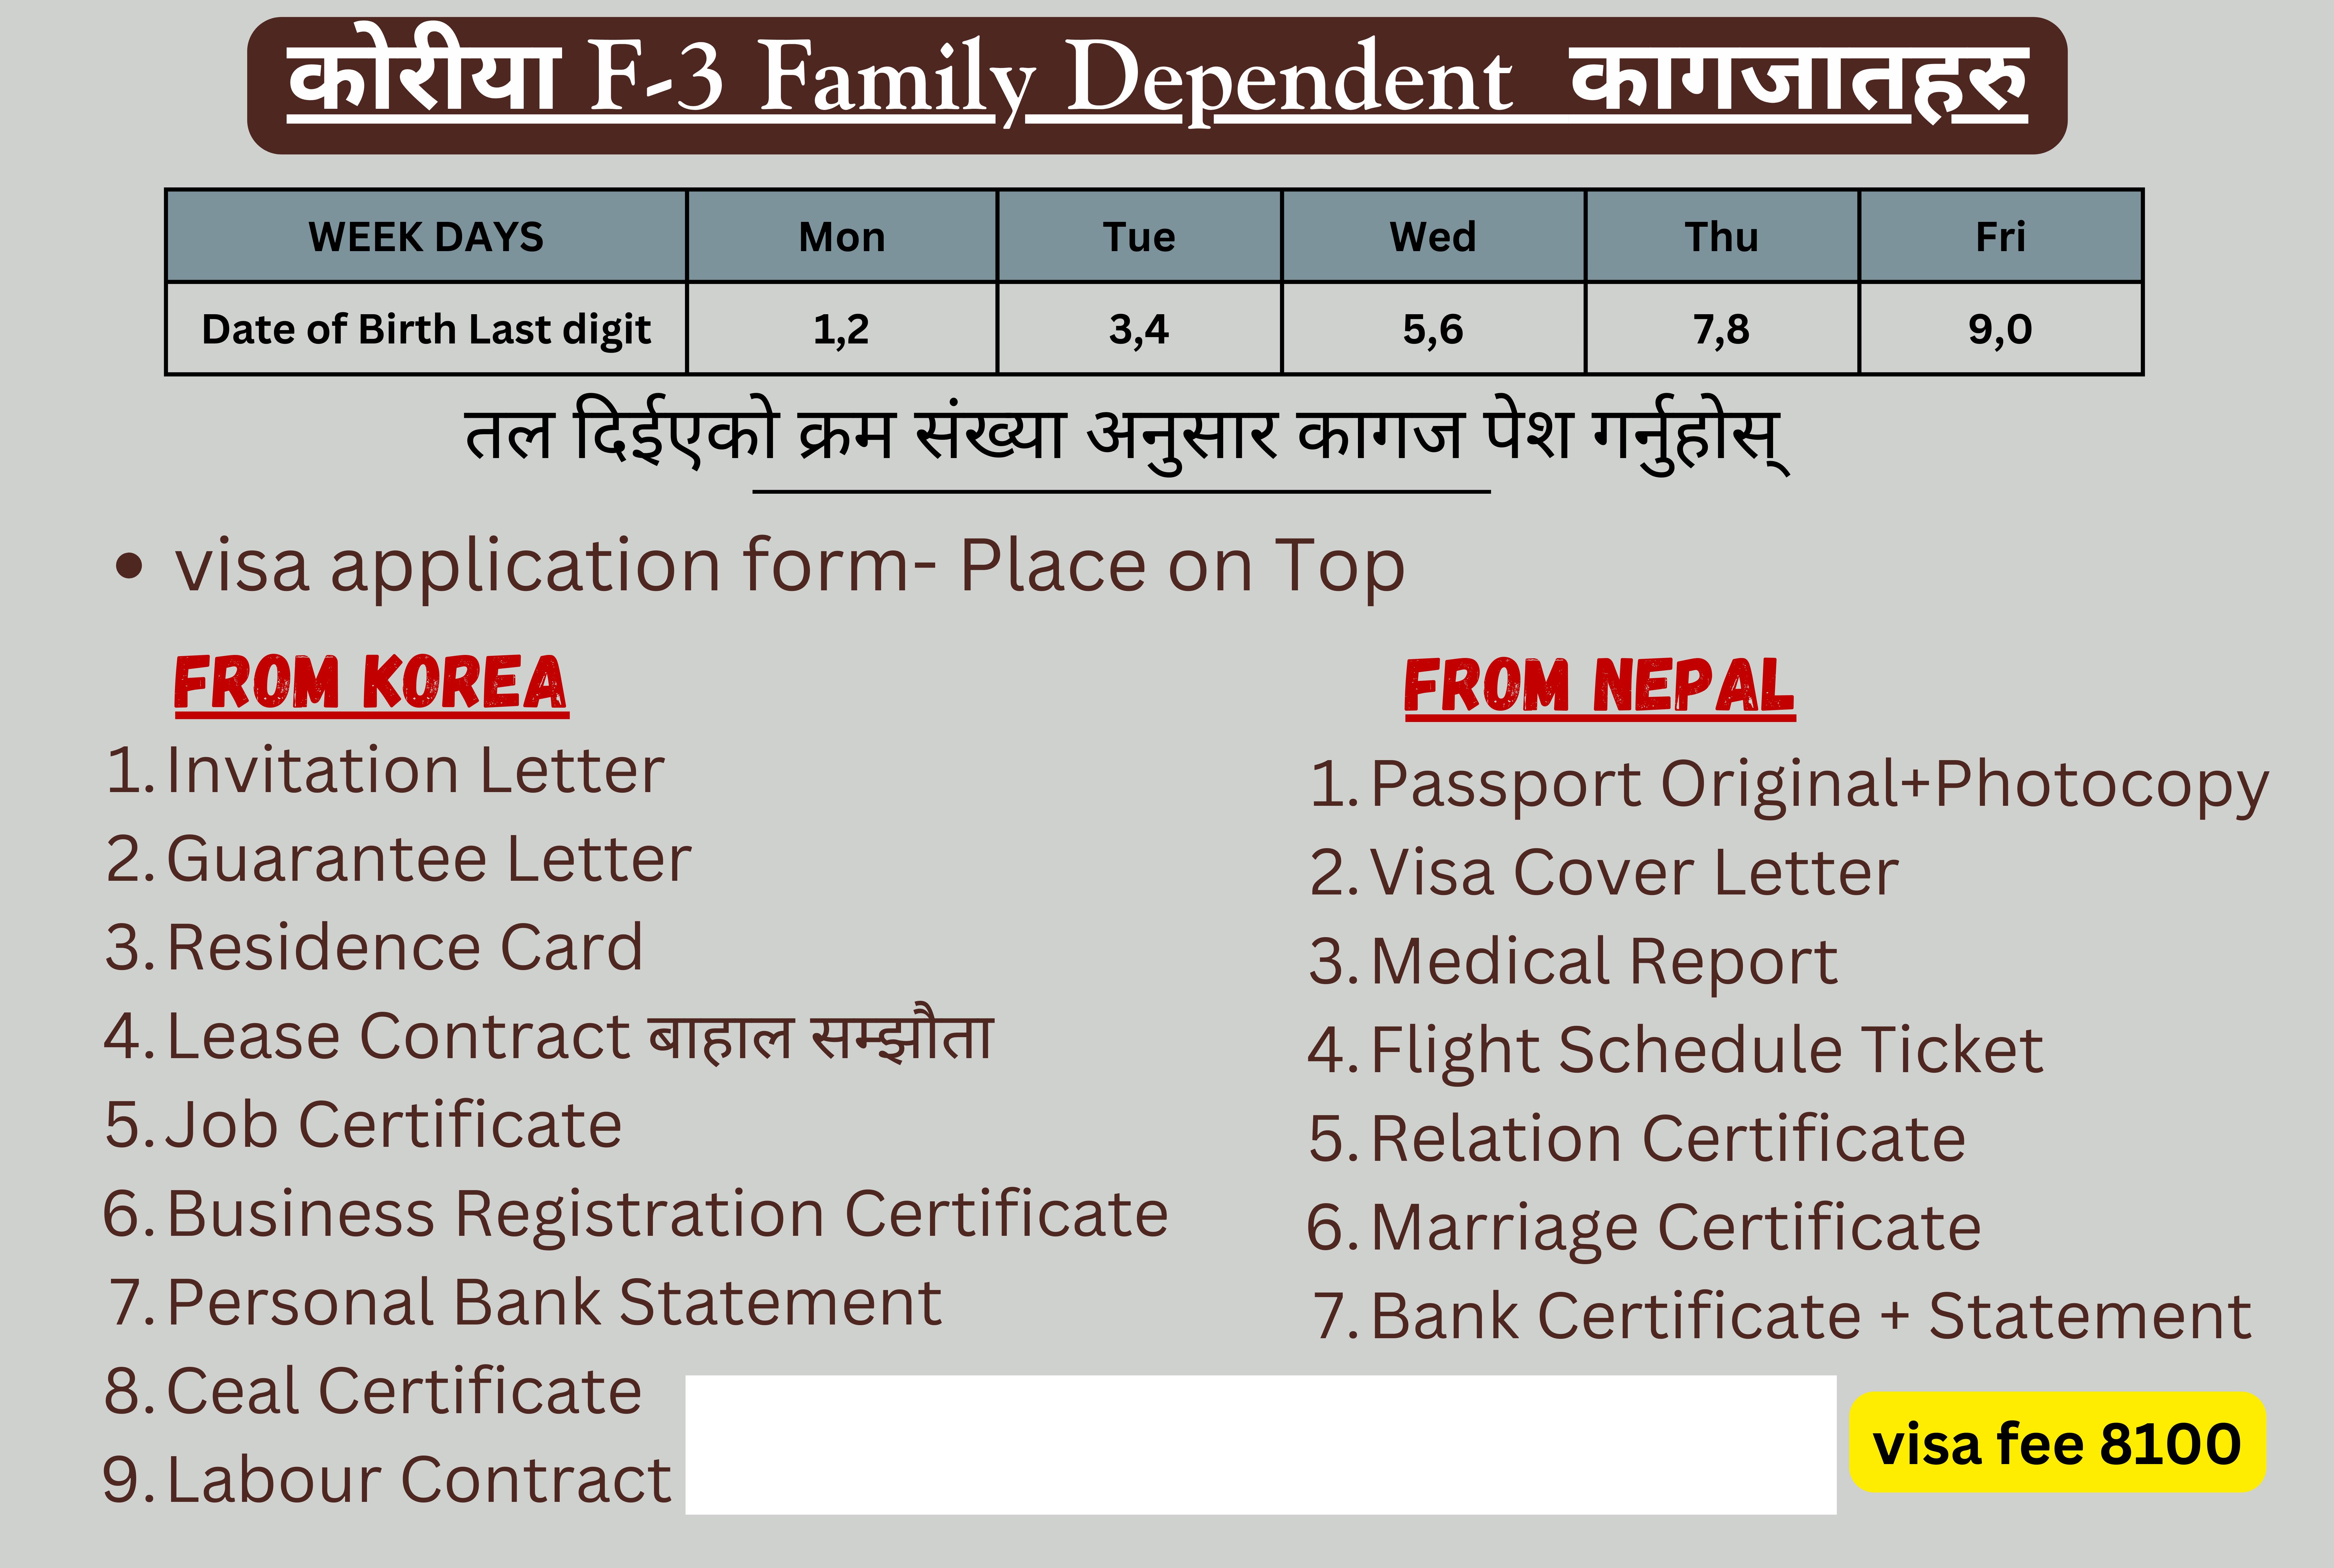

Thank You Very Much!!

Please Subscribe our Youtube Channel

https://www.youtube.com/@saralonline

